PF LAB TASK 2 AND 3

NAME: MALIK MUHAMMAD ESSA
SECTION: BSE-1B
ROLL NO: 26P-3071

QUESTION#1: Average Speed
A car travelled for some hours. Take the number of hours travelled and the distance travelled
during this time as input at runtime. Write a C program to calculate the average speed and
display it on the screen. Use hours for time and kilometres for distance; assume the time is
positive and the distance is nonnegative. Display the speed in kilometres per hour.
#include<stdio.h>
int main(){

int hour;
int distance;
int avg_speed;
printf("Enter First Number:");
scanf("%d", &hour);
printf("Enter Second Number:");
scanf("%d", &distance);
//formula
avg_speed = distance/hour;
printf("The Average Speed Is:%d\n",avg_speed);
return 0
}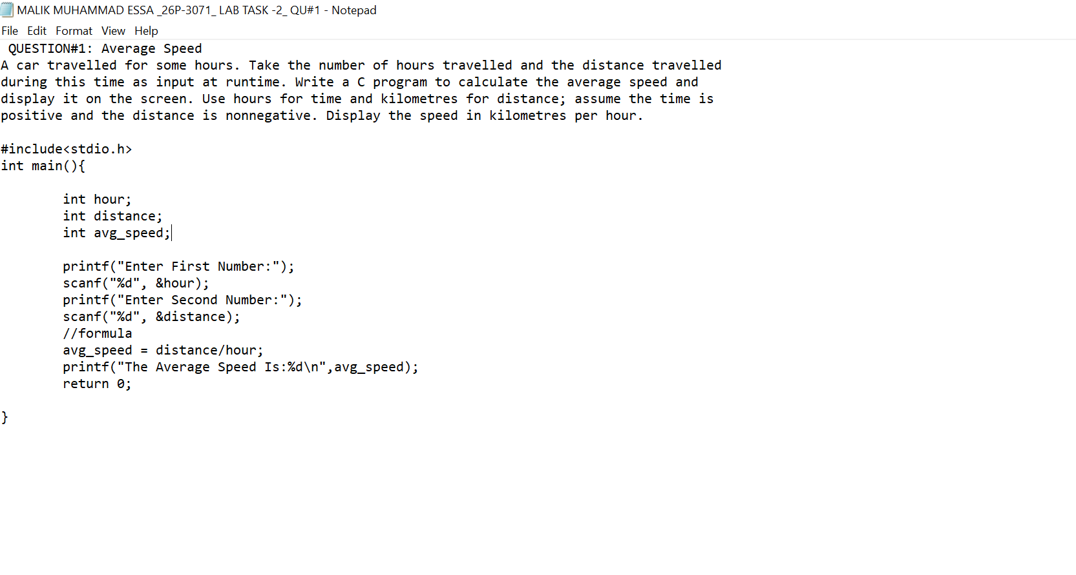
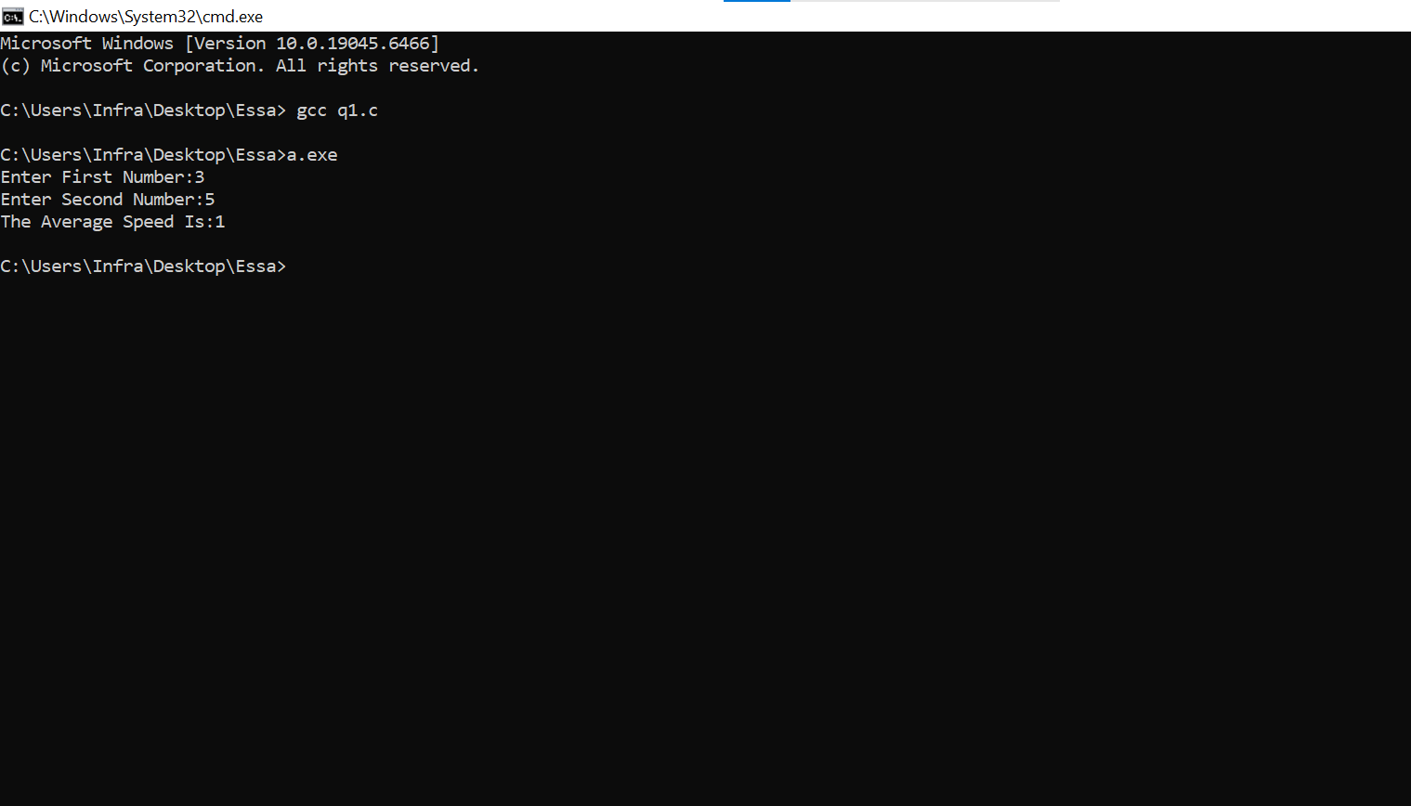

QUESTION#2: Swapping Two Values
Write a C program that takes two integer values as input from the user. Swap the values and
display both variables after swapping. The original value of num1 should be stored in num2, and
the original value of num2 should be stored in num1.

#include<stdio.h>
int main()
{
int num1;
int num2;
int temp;

printf("enter first number:");S
scanf("%d", &num1 );
printf("enter second number:");
scanf("%d", &num2);
//swapping
temp = num1;
num1 = num2;
num2 = temp;
printf("after swapping:\n");
printf("num1: %d\n",num1);
printf("num2: %d\n",num2);
return 0;
}
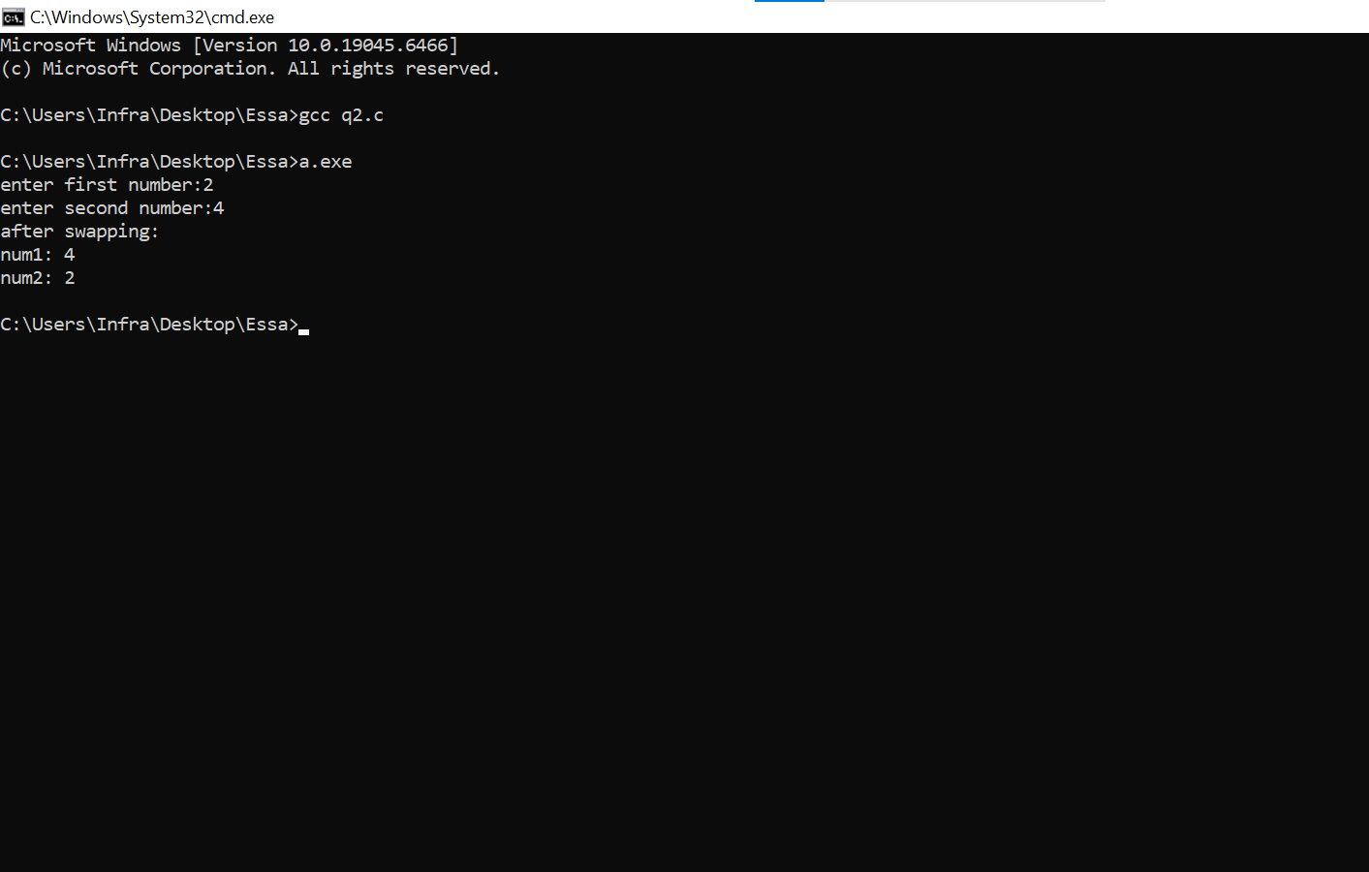
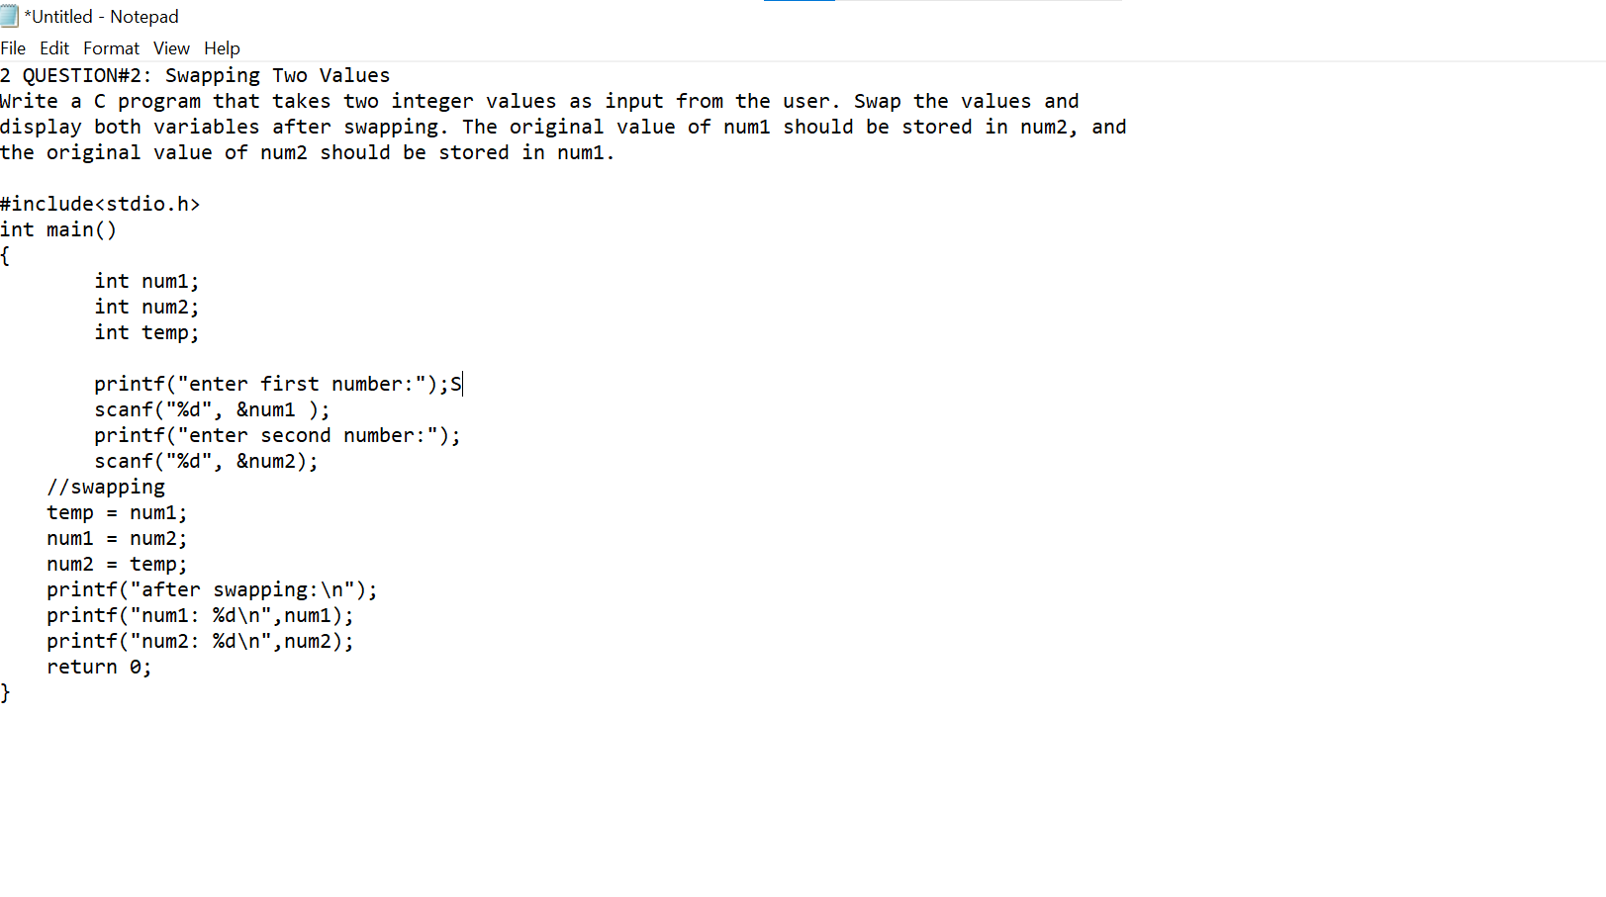
QUESTION#3: Salary After Tax
A customer asks an IT rm to develop a program in C that takes a tax rate and salary from
the user at runtime. Calculate the tax payable and the salary remaining after paying the tax.
Display the tax amount and net income after the deduction. Enter the tax rate as a percentage
from 0 to 100 and assume a nonnegative salary.

#include,stdio.h>
int main(){

int tax_rate;
int salary;

printf("Tax Rate Is:");
scanf("%d", &tax_rate);
printf("Total Salary Is:");
scanf("%d", &salary);

int tax_amount;
int net_income;
//formula
tax_amount = salary*tax_rate/100;
net_income = salary-tax amount;
printf("tax amount is:%d\n",tax_amount);
printf("the net income is:%d\n",net_income);
return 0;
}

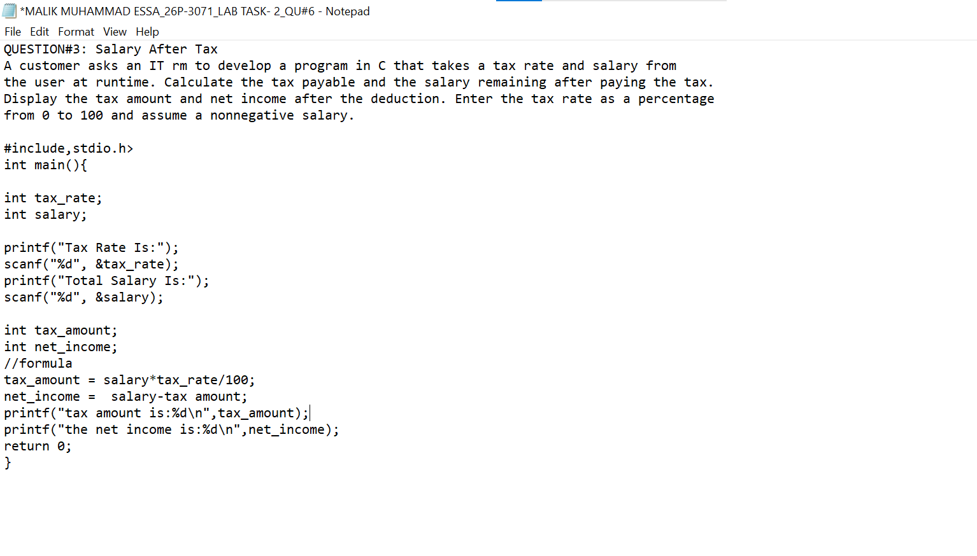

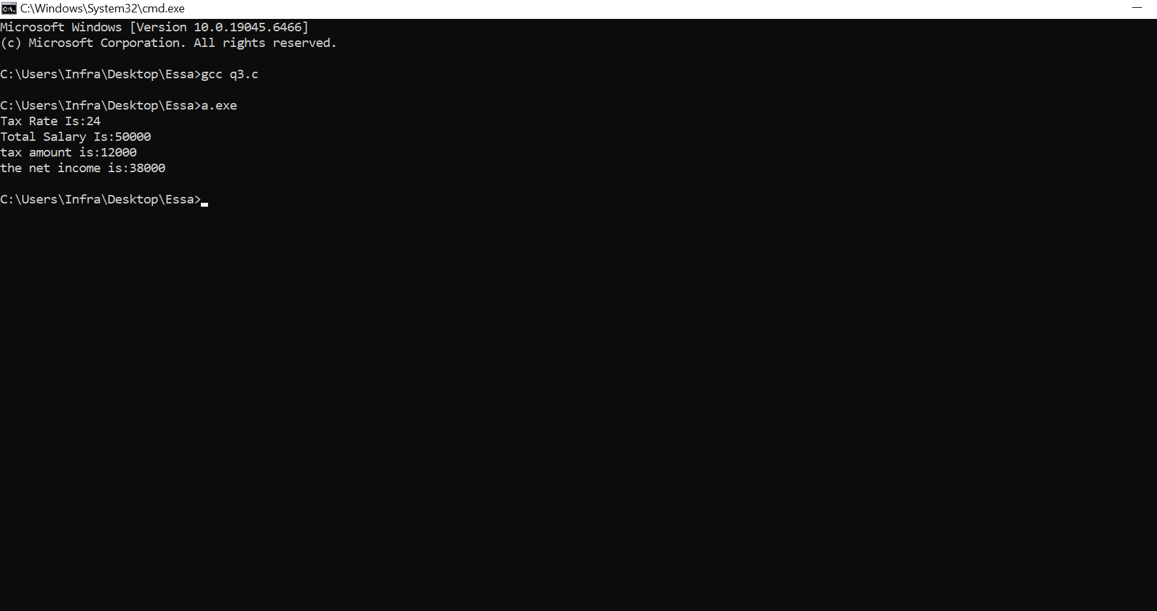

QUESTION#4: Converting Pennies into Coins
Ali visited his grandmother, and she handed him 368 pennies as a gift. Carrying so many coins
would be a hassle, so Ali wishes to convert these 368 pennies into a better format. Write a
C program that distributes this amount into quarters, dimes, nickels, and pennies so that Ali
carries the least number of coins. Display the number of each coin type. Use the following
denitions:
▶ 1 quarter = 25 pennies
▶ 1 dime = 10 pennies
▶ 1 nickel = 5 pennies

#include<stdio.h>
int main()
{
int pennies = 368;
//convert pennies into qurters,dime,nickel

int quarter;
int dime;
int nickel;

//Given

quarter = pennies/25;
pennies = pennies%25;
dime = pennies/10;
pennies = pennies%10;
nickel = pennies/5;
pennies = pennies%5;

printf("Quarter:%d\n",quarter);
printf("Dime:%d\n",dime);
printf("Nickel:%d\n",nickel);
printf("Pennies:%d",pennies);
return 0;
}

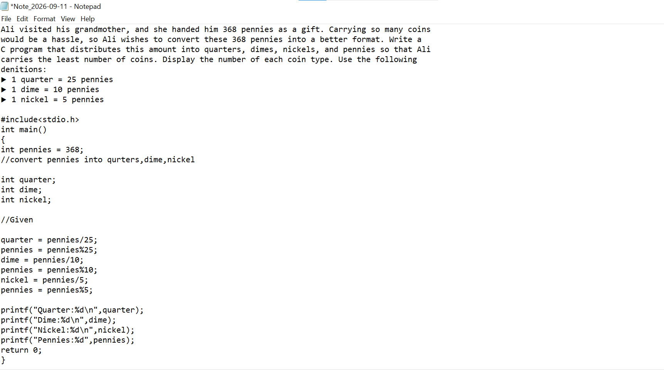

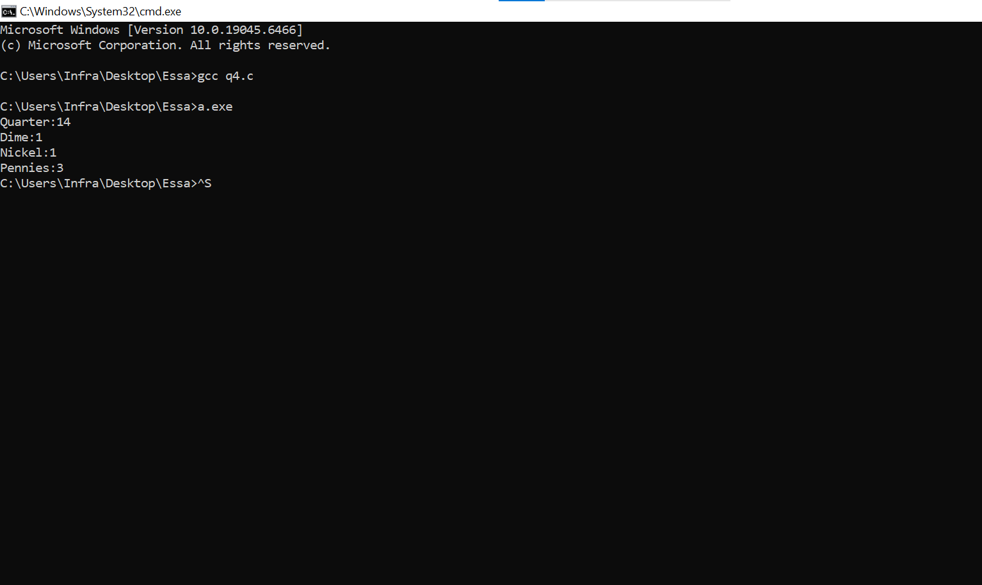

QUESTION#5: Roots of a Quadratic Equation
Write a C program that takes a, b, and c as input and nds both roots of the quadratic equation
ax2 + bx + c = 0 using the formulas:
x1 =−b +√b2 − 4ac/2a, x2 =−b −√b2 − 4ac/2a.
Assume a ̸= 0 and b2 − 4ac ≥ 0, so both roots are real. Display both roots. Include math.h to
use sqrt. When compiling with GCC on Linux, link the math library using gcc quadratic.c
-o quadratic -lm.

#include<stduo.h>
#include<math.h>
int main()
{
int a;
int b;
int c;

printf("enter a:");
scanf("%d", &a);
printf("enter b:");
scanf("%d", &b);
printf("enter c:");
scanf("%d", &c);

float x1;
float x2;
float discriminent;

discriminent = b*b-4*a*c;
x1 = (-b+sqrt(discriminent))/(2*a);
x2 = (-b-sqrt(discriminent))/(2*a);

printf("first root:%.2f\n",x1);
printf("second root:%.2f\n",x2);

return 0;
}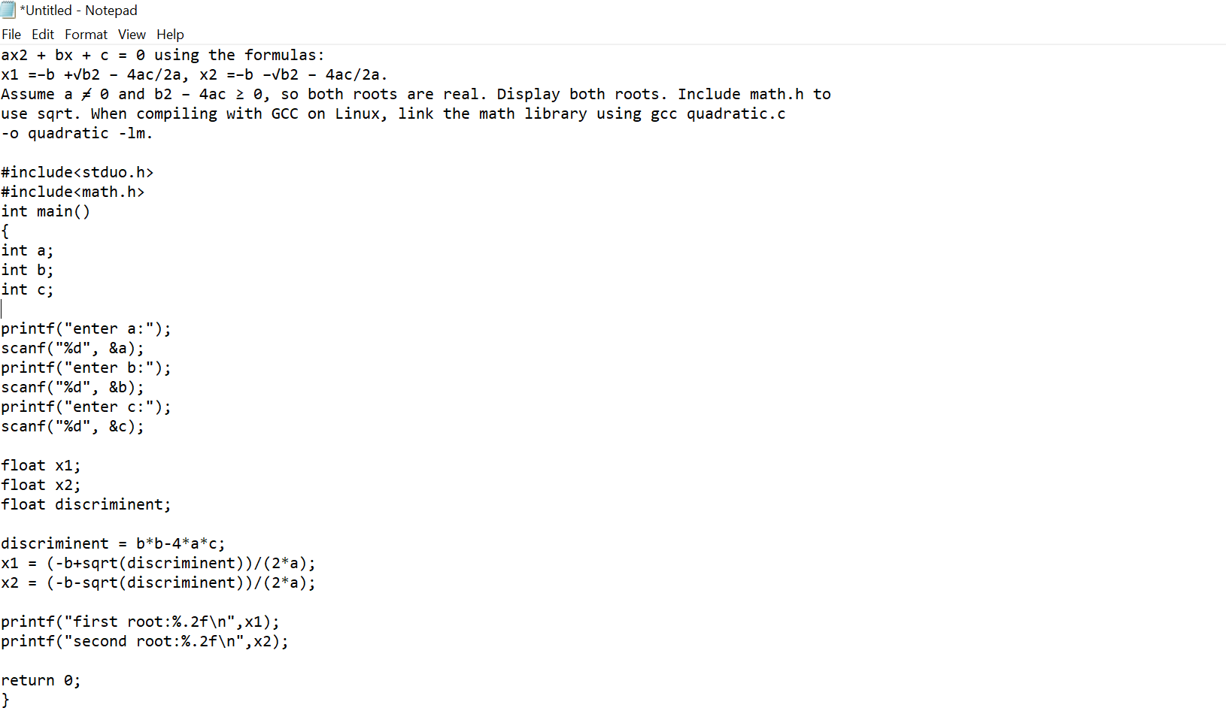

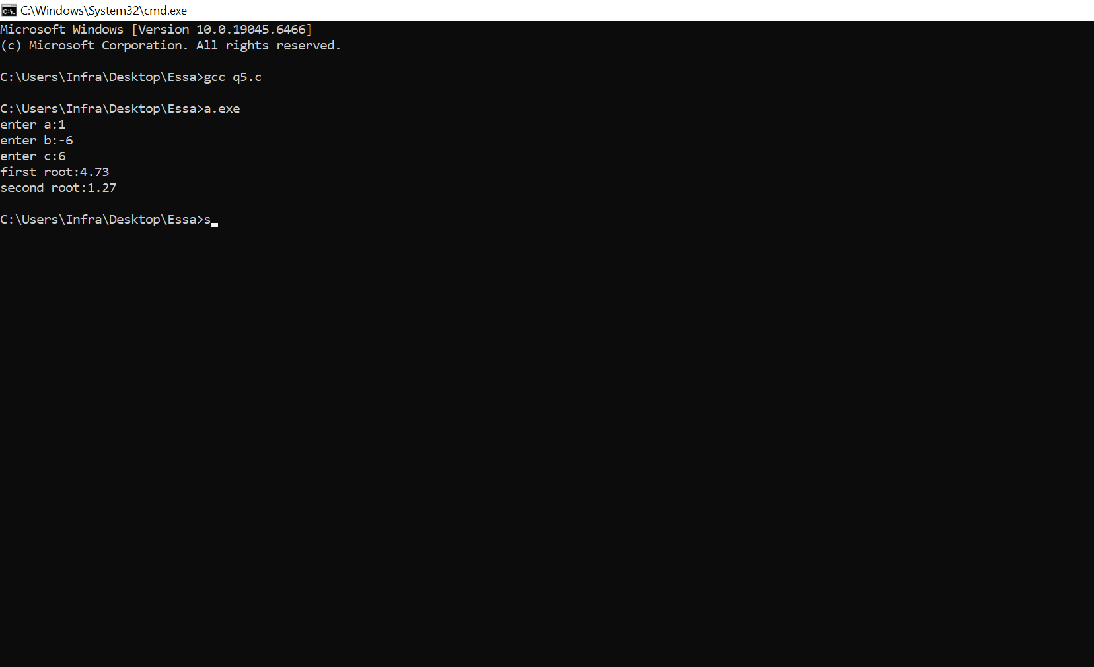

QUESTION#6: Typecasting Before and After Division
Write a C program that takes two positive integers, a and b, as input. Evaluate each of the
following expressions and store each result in a separate float variable:
a) a / b
b) (float) a / b
c) (float) (a / b)
Display all three results. Test your program with a = 7 and b = 2, then explain why casting
before division can produce a dierent result from casting after division.

#include<stdio.h>
int main()
{
int a;
int b;

printf("enter a:");
scanf("%d", &a);
printf("enter b:");
scanf("%d", &b);

//type casting
float c = a/b;
float d = (float) a/b;
float e = (float) (a/b);

printf("%f\n",c);
printf("%f\n",d);
printf("%f\n",e);
return 0;
}

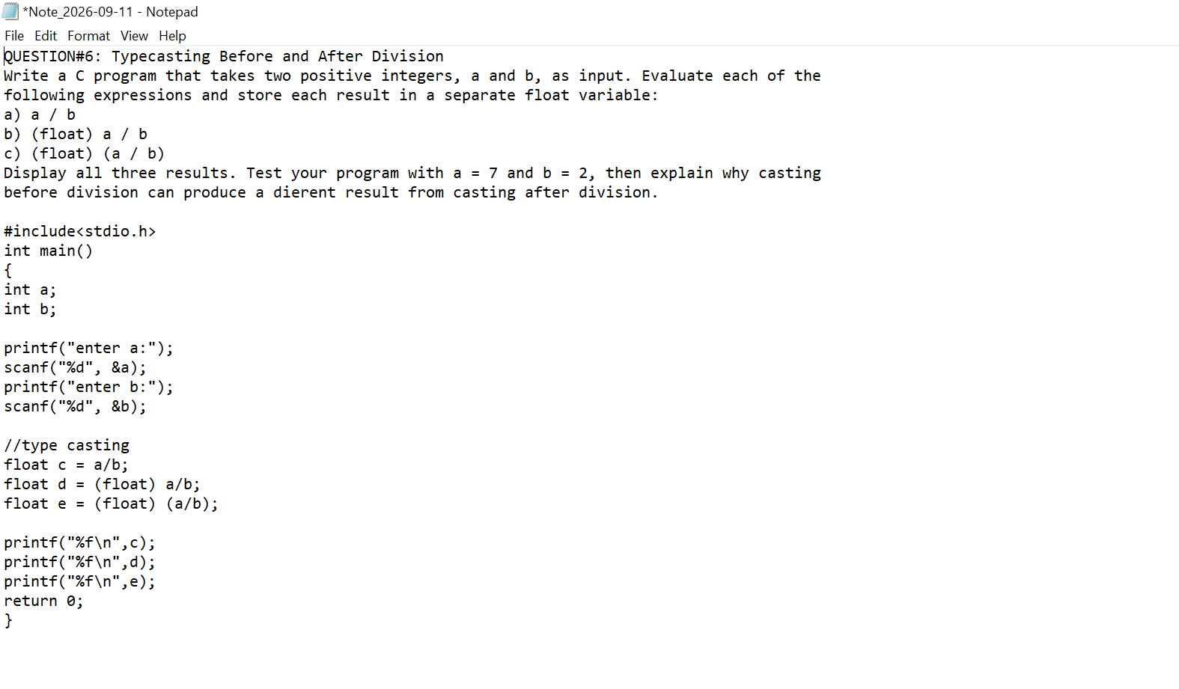
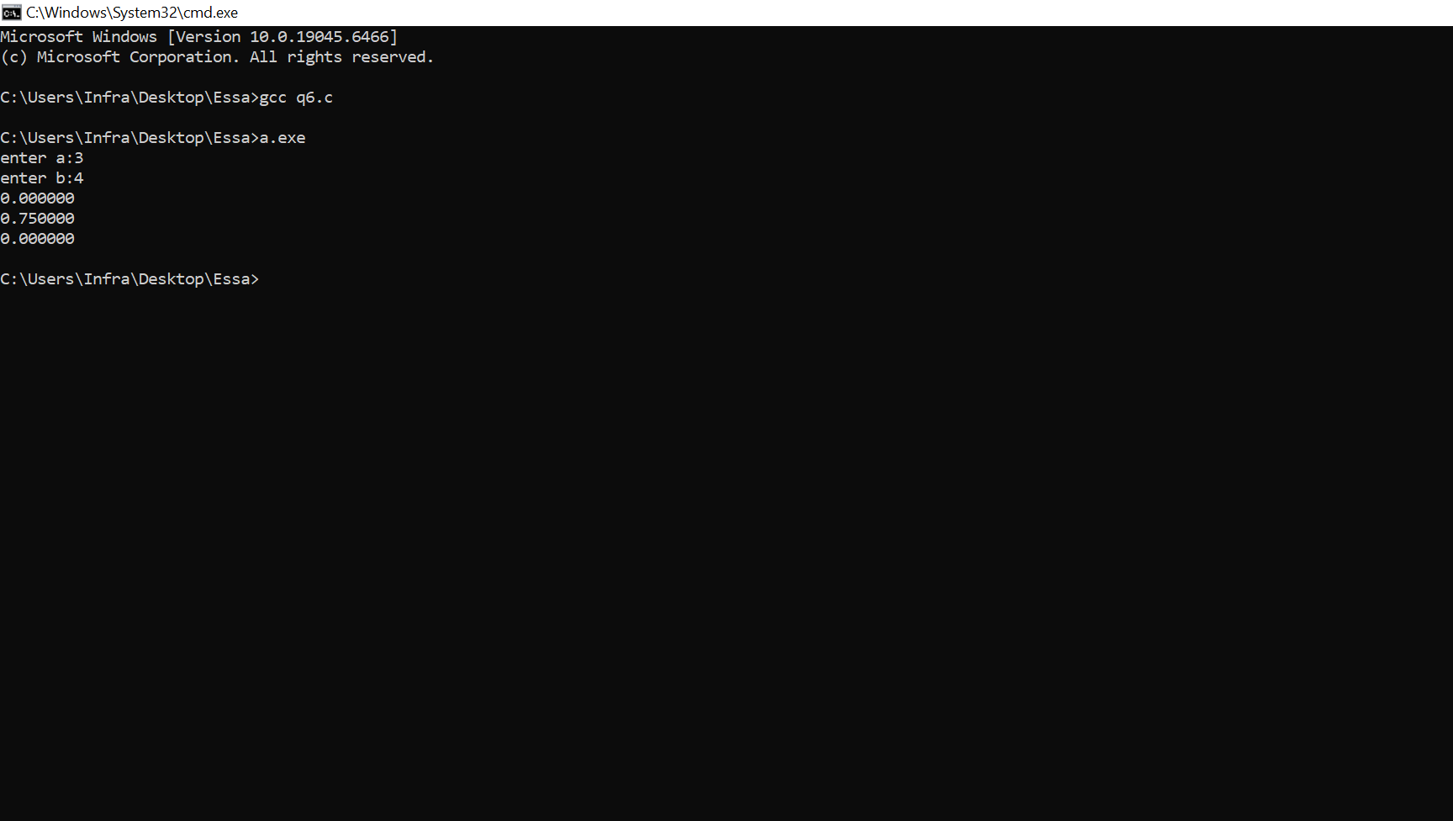

QUESTION#7:
Average Marks Using Typecasting
Write a C program that takes integer marks for three subjects, each from 0 to 100. Store the
total in an integer variable. Use an explicit cast to calculate the average as a float without
losing the fractional part. Display the total and average. Test your program with marks 70, 75,
and 80, and then with 70, 75, and 81 to show both a whole and a fractional average.*/

#include<stdio.h>
int main()
{
int sub1;
int sub2;
int sub3;

printf("enter ubject 1:");
scanf("%d", &sub1);
printf("enter subjectb 2:");
scanf("%d", &sub2);
printf("enter subject 3:");
scanf("%d", &sub3);

int total_marks;
float avg;
//formulas
total_marks = sub1+sub2+sub3;
avg =(float )(total_marks/3);

printf("total marks is:%d\n",total-marks);

printf("the avg is:%f\n",avg);
return 0;
}

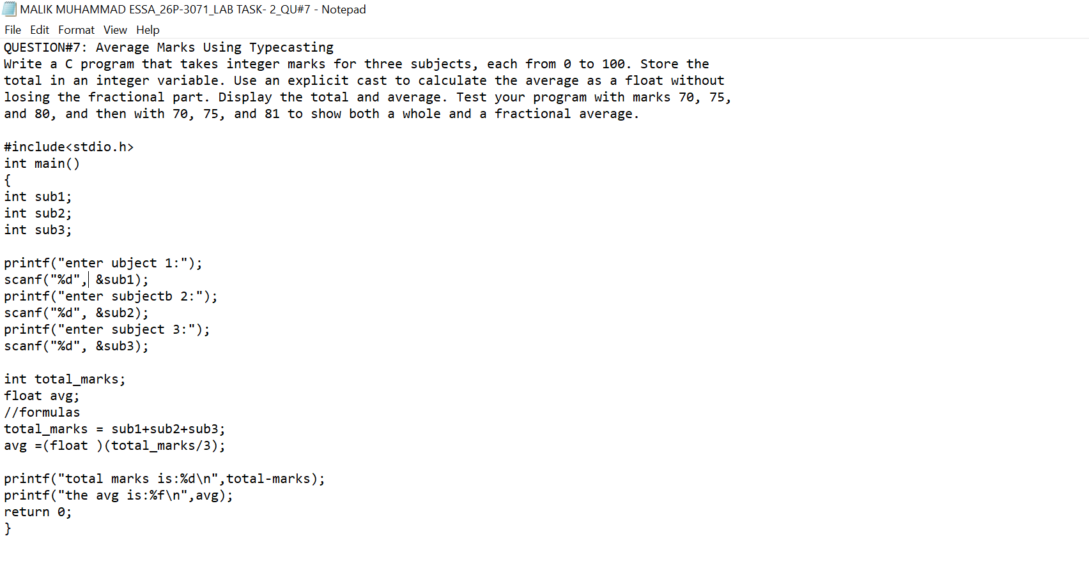

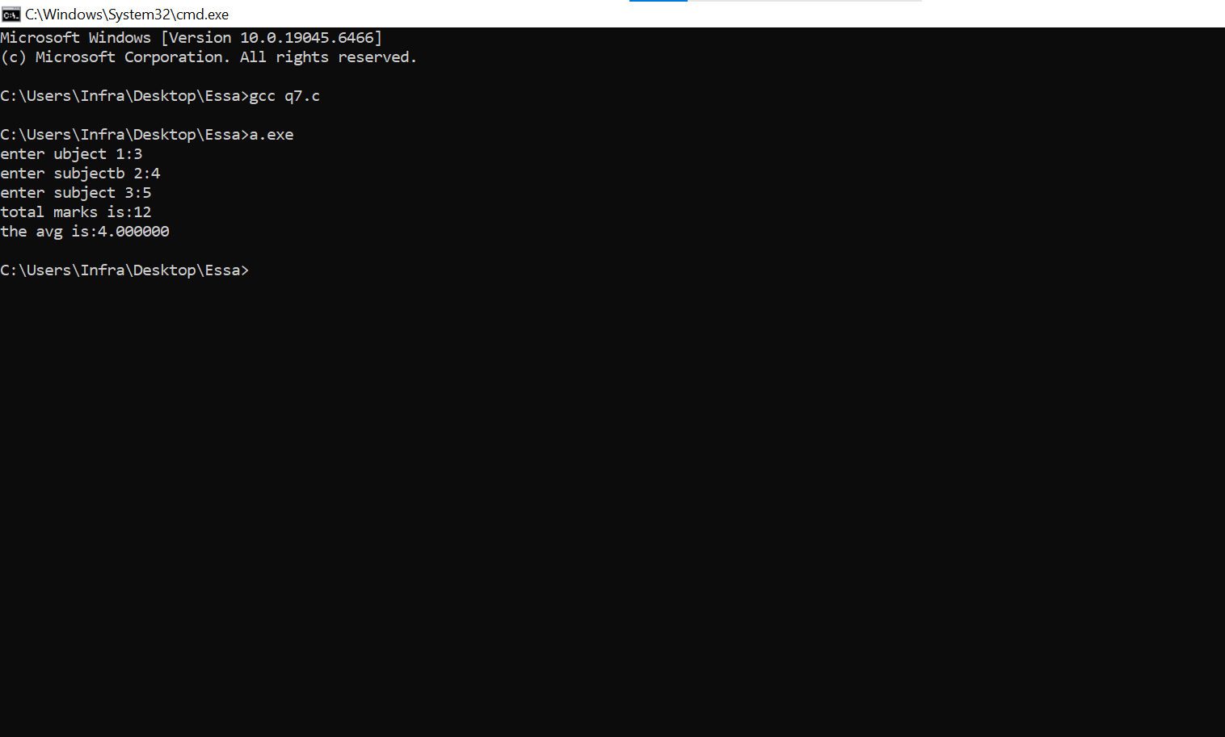

QUESTION#8: Converting a Float to an Integer
Write a C program that takes a float value between -1000 and 1000 as input. Use an explicit
cast to store it in an int variable. Display the original value, the converted integer, and the
dierence between the original value and the converted integer. Test your program with 19.75
and -3.80. Explain whether the cast rounds the value or discards its fractional part.

#include<stdio.h>
int main()
{
float orignal_value;

printf("enter orignal value:");
scanf("%f", &orignal_value);

//float conversion

int converted_value;
converted_value = (int) orignal_value;

printf("converted value:%d\n",converted_value);

//difference

float difference;
differnce = orignal_value-converted_value;

printf("difference value:%f\n",difference);
return 0;
}

